**Final Report of Traineeship Program 2020**

On

**“BLOOD DONATION PREDICTION”**

**MEDTOUREASY**



22nd June 2023

**Final Report of Traineeship Program 2023**

**Prepared By: Yash Jadhav**

**DATA ANALYST INTERN**

**GIT HUB REPO:** **https://github.com/VORPAL04/PREDICT-BLOOD-DONATIONS**

**ACKNOWLDEGMENTS**

I am immensely grateful for the invaluable traineeship opportunity I had with MedTourEasy, which proved to be a transformative experience for my personal and professional growth. During my time with the organization, I had the privilege to delve into the intricacies of Data Visualizations in Data Analytics and expand my knowledge in this field. I would like to express my heartfelt appreciation to the professionals who guided and mentored me throughout the traineeship, contributing to an enriching learning curve.

First and foremost, I extend my deepest gratitude to the Training & Development Team at MedTourEasy for providing me with this valuable opportunity to undertake my traineeship at their esteemed organization. Their belief in my potential and their willingness to nurture my growth in the field of Data Analytics is truly appreciated. I am grateful for their continuous support and encouragement throughout the project.

I would also like to extend my sincere thanks to the entire team at MedTourEasy for creating a conducive and productive working environment. Their collaborative spirit, expertise, and willingness to share knowledge greatly enhanced my learning experience. Their guidance and constructive feedback were instrumental in shaping the success of the traineeship project.

Additionally, I am indebted to for their exceptional support and mentorship. Their dedication, patience, and willingness to share their expertise significantly contributed to my understanding of Data Visualizations in Data Analytics. Despite their busy schedules, they consistently made time to provide valuable insights and guidance, which I am truly grateful for.

Furthermore, I would like to acknowledge the MedTourEasy team for fostering a culture of continuous learning and growth. The collective knowledge and expertise within the organization created an environment that fostered collaboration and encouraged innovation.

Lastly, I would like to express my gratitude to all the individuals who directly or indirectly contributed to my traineeship experience at MedTourEasy. Their guidance, support, and encouragement were instrumental in making this journey a memorable and fruitful one.

**TABLE OF CONTENTS**

Acknowledgments .................................... i

Abstract ..................................................... iii

|  |  |  |
| --- | --- | --- |
| **Sr. No.** | **TOPIC** | **Page No.** |
| **1.** | **INTRODUCTION** |  |
|  | 1.1 About the Company |  |
|  | 1.2 About the Project |  |
|  | 1.3 Objectives and Deliverables |  |
| **2.** | **METHODOLOGY** |  |
|  | 2.1 Flow of the Project |  |
|  | 2.2 Use Case Diagram |  |
|  | 2.3 Language and Platform Used |  |
| **3.** | **IMPLEMENTATION** |  |
|  | 3.1 Gathering Requirements and Defining Problem Statement |  |
|  | 3.2 Data Collection and Importing |  |
|  | 3.3 Designing Databases |  |
|  | 3.4 Data Cleaning |  |
|  | 3.5 Data Filtering |  |
|  | 3.6 Prototyping - Power BI, IBM COGNOS |  |
|  | 3.7 Development of Dashboards |  |
| **4.** | **Sample Screenshots and Observations** |  |
|  |  |  |
| **5.** | **CONCLUSION** |  |
| **6.** | **FUTURE SCOPE** |  |
| **8.** | **REFERENCES** |  |
|  |  |  |
|  |  |  |

**ABSTRACT**

This report presents a detailed analysis of my traineeship experience at MedTourEasy, with a specific focus on the subject of Data Visualizations in Data Analytics. The traineeship provided a transformative opportunity for learning and professional development, enabling me to gain in-depth knowledge and practical skills in the field. The report highlights the various learning opportunities, mentorship, and guidance received throughout the traineeship period, while expressing gratitude towards the Training & Development Team, colleagues, mentors, and the overall working environment at MedTourEasy.

The traineeship project revolved around the application of data visualizations in the context of data analytics. The project aimed to explore the potential of visual representations to enhance data analysis and decision-making processes. Through the project, I had the opportunity to work on real-world datasets, apply data visualization techniques, and develop interactive dashboards for data exploration and presentation.

The report outlines the objectives and scope of the traineeship project, highlighting its relevance to the field of Data Visualizations in Data Analytics. It also provides insights into the methodologies and tools employed during the project, including data collection, cleaning, and visualization libraries or platforms utilized.

The traineeship experience at MedTourEasy was characterized by a collaborative and supportive working environment. Colleagues and mentors played a crucial role in facilitating knowledge sharing and providing guidance throughout the project. Their expertise and willingness to assist were instrumental in my learning and growth.

The report delves into the personal and professional development achieved during the traineeship. It elaborates on the acquired knowledge and skills related to data visualizations and their practical applications in data analytics. Furthermore, it emphasizes the importance of networking and building professional relationships, highlighting the opportunities for interaction with industry professionals and the benefits derived from such connections.

In conclusion, this report provides a comprehensive account of my traineeship experience at MedTourEasy, emphasizing the significance of the subject of Data Visualizations in Data Analytics. It showcases the value of the mentorship, collaborative working environment, and practical learning opportunities offered during the traineeship. The report serves as a testament to the gratitude expressed towards MedTourEasy, the Training & Development Team, colleagues, mentors, and all those who contributed to the enriching traineeship journey.

**1.1 About the Company**

MedTourEasy is a leading healthcare organization specializing in medical tourism and comprehensive healthcare solutions. The company connects patients with top-tier international healthcare providers, ensuring access to high-quality medical treatments. MedTourEasy prioritizes patient satisfaction, offering personalized guidance throughout the medical journey.

With a focus on transparency and ethical practices, the company provides detailed information to empower patients in making informed healthcare decisions. MedTourEasy leverages advanced technologies and invests in employee training to deliver efficient and exceptional healthcare experiences.

Moreover, MedTourEasy recognizes the significance of continuous learning and professional development. The company invests in the training and development of its employees, fostering a culture of expertise and excellence in the healthcare industry. This commitment to knowledge advancement ensures that MedTourEasy remains at the forefront of the evolving healthcare landscape.

Overall, MedTourEasy is a prominent player in the medical tourism sector, renowned for its commitment to patient-centric care, extensive network of healthcare providers, and dedication to quality and transparency. The organization's focus on innovation, continuous learning, and personalized healthcare experiences positions it as a leader in the industry, serving as a trusted partner for individuals seeking comprehensive and reliable healthcare solutions.

**1.2 About the Project**

The "PREDICT-BLOOD-DONATIONS" project aims to develop a data-driven solution for predicting blood donations. The project recognizes the challenge of maintaining a consistent and sufficient blood supply for transfusions and seeks to optimize blood collection efforts through advanced data analysis and machine learning techniques.

The project involves several stages of implementation, starting with meticulous requirement gathering to understand the specific needs and objectives. Data collection is then conducted, sourcing diverse datasets related to blood donations. These datasets are imported and subjected to rigorous data cleaning processes to ensure data accuracy and reliability.

Following data cleaning, the project involves designing databases to organize and store the collected data efficiently. This step enables easy access and retrieval of the data for further analysis. Data filtering techniques are applied to identify relevant factors and variables that can impact blood donation behaviour.

Prototyping is an integral part of the project, where the team utilizes Power BI, a powerful data visualization tool, to create interactive and visually appealing representations of the collected data. These prototypes allow stakeholders to gain valuable insights into blood donation patterns and trends.

The project also focuses on the development of dashboards, which provide a comprehensive overview of blood donation metrics, including donor demographics, donation frequency, and potential donor retention strategies. These dashboards empower decision-makers to make informed choices regarding blood collection strategies, thereby optimizing the efficiency of the process.

In conclusion, the "PREDICT-BLOOD-DONATIONS" project is dedicated to leveraging data analysis and machine learning techniques to predict blood donations accurately. By optimizing blood collection efforts, this project aims to ensure a consistent and adequate supply of blood for transfusions, ultimately contributing to improved healthcare outcomes.

**1.3 Objectives and Deliverables**

* **Objectives:**

1. Predictive Modelling: Develop a robust predictive model that can accurately forecast blood donations based on various factors and variables.

2. Optimize Blood Collection: Utilize the predictive model to optimize blood collection efforts by identifying patterns, trends, and factors that influence donation behaviour.

3. Increase Donor Retention: Identify strategies and factors that contribute to donor retention and develop recommendations to enhance donor loyalty and engagement.

4. Data-driven Decision Making: Enable stakeholders to make informed decisions regarding blood collection strategies by providing comprehensive insights and visualizations through dashboards and reports.

* **Deliverables:**

1. Predictive Model: A well-performing predictive model that accurately predicts blood donations based on collected data, allowing for proactive planning and resource allocation.

2. Data Analysis and Insights: Comprehensive analysis of the collected data, highlighting trends, patterns, and factors influencing blood donation behaviour. This analysis will provide valuable insights for optimizing blood collection efforts.

3. Visualization Dashboards: Interactive dashboards that present key metrics and visual representations of blood donation patterns, donor demographics, and retention strategies. These dashboards will facilitate data-driven decision-making and provide a user-friendly interface for exploring the data.

4. Recommendations and Strategies: Based on the analysis and insights gained from the project, deliver recommendations and strategies to enhance donor retention, improve blood collection efficiency, and increase the overall effectiveness of the blood donation process.

5. Documentation: Detailed documentation of the project, including methodologies, data sources, preprocessing techniques, model development, and visualization approaches. This documentation will serve as a reference for future analyses and implementations.

6. Presentation and Training: Conduct presentations and training sessions to share the project findings, methodologies, and outcomes with stakeholders and team members. This will ensure understanding and utilization of the developed predictive model and insights.

Overall, the project aims to deliver a predictive model, data analysis, visualization dashboards, recommendations, and comprehensive documentation to optimize blood collection efforts, enhance donor retention, and enable data-driven decision-making in the context of blood donation prediction.

**METHODOLOGY**

**USE CASES**

Actors:

Administrator: Responsible for managing the system, accessing reports, and overseeing the prediction process.

Data Analyst: Utilizes the system for data analysis, model development, and generating insights.

Donor: Engages with the system to provide relevant data for prediction and receives information regarding blood donation.

Use Cases:

Input Donor Data: The donor interacts with the system to input their relevant data, including demographics, donation history, and other relevant factors.

Preprocess Data: The data analyst processes and cleans the collected donor data to ensure accuracy and reliability.

Train Model: The data analyst utilizes the pre-processed data to train the predictive model using suitable machine learning algorithms.

Predict Blood Donations: The system applies the trained model to predict the likelihood of future blood donations based on input donor data.

Generate Reports: The administrator generates reports and visualizations based on the prediction results and analysis conducted by the data analyst.

Relationships:

Actors interact with the system to perform specific use cases.

The system interacts with the predictive model for training and prediction purposes.

The administrator interacts with the system to generate reports and access relevant functionalities.

The data analyst utilizes the system to preprocess data**,** train the model, and analyse results

**Language and Platform Used**

1. Programming Language: Python

- Python is widely utilized in data analytics and machine learning projects due to its extensive libraries and frameworks. It provides a rich ecosystem for data manipulation, statistical analysis, and machine learning model development.

2. Data Analysis and Machine Learning Libraries:

- Pandas: A powerful data manipulation library in Python, used for data preprocessing, cleaning, and filtering.

- NumPy: Provides efficient numerical operations and mathematical functions, often used for handling large arrays and matrices.

- Scikit-learn: A popular machine learning library in Python, offering various algorithms for predictive modelling, model evaluation, and optimization.

- TensorFlow or PyTorch: Deep learning frameworks used for developing and training neural networks, particularly for advanced predictive modelling tasks.

3. Data Visualization Tools:

- IBM COGNOS: A comprehensive business intelligence tool that enables interactive and visually appealing data visualization and dashboard creation.

- Matplotlib: A widely-used plotting library in Python for generating static, animated, or interactive visualizations.

- Seaborn: Built on top of Matplotlib, Seaborn provides additional functionalities and aesthetics for statistical data visualization.

4. Integrated Development Environment (IDE):

- Jupyter Notebook or JupyterLab: Interactive coding environments that facilitate data exploration, analysis, and model development using Python. They allow for the integration of code, visualizations, and explanatory text in a single document.

These language and platform choices enable efficient data preprocessing, model development, and visualization for the "PREDICT-BLOOD-DONATIONS" project. They provide a robust foundation to implement the required functionalities and deliver accurate predictions and meaningful insights.

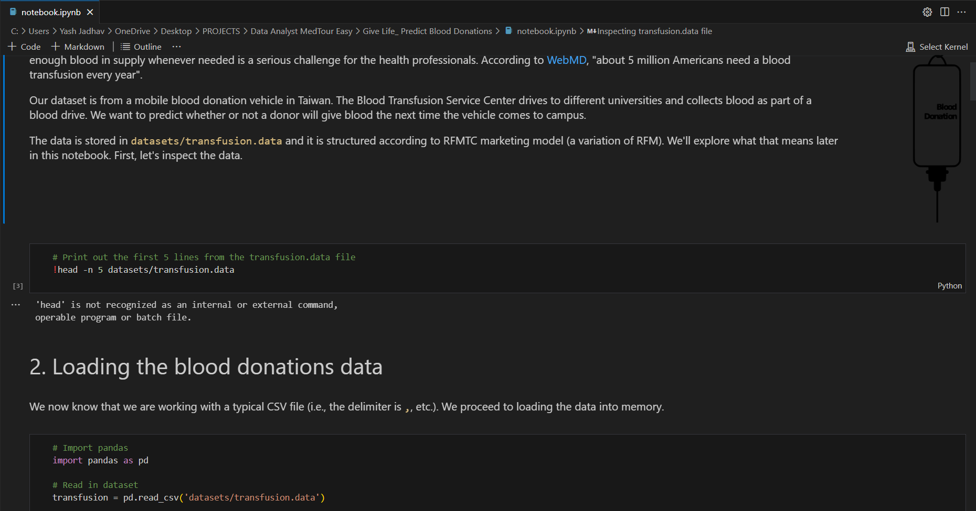

**IMPLEMENTATION**

The implementation of the "PREDICT-BLOOD-DONATIONS" project involves several key steps, from gathering requirements to developing the predictive model and creating visualization dashboards. Here is a brief overview of the implementation process:

1. Gathering Requirements and Defining Problem Statement:

- Conduct thorough discussions with stakeholders to understand their requirements and objectives.

- Define the problem statement clearly, including the specific variables and factors to be considered for predicting blood donations.

2. Data Collection and Importing:

- Collect diverse datasets related to blood donations from reliable sources such as blood banks, donor registries, and healthcare institutions.

- Import the collected data into a suitable data storage system for further analysis.

3. Data Cleaning:

- Perform data cleaning procedures to address missing values, duplicates, and inconsistencies in the collected data.

- Standardize data formats and handle any outliers or anomalies present.

4. Designing Databases:

- Create an efficient database schema to organize and store the cleaned data.

- Determine appropriate data tables and relationships to facilitate easy data retrieval and analysis.

5. Data Filtering:

- Apply data filtering techniques to identify the relevant variables and factors that influence blood donation behaviour.

- Analyse correlations and conduct statistical tests to determine the significant variables for the predictive model.

6. Prototyping - Power BI:

- Utilize Power BI or other data visualization tools to create interactive prototypes and visual representations of the collected data.

- Design visually appealing and informative visualizations to gain initial insights into blood donation patterns and trends.

7. Development of Predictive Model:

- Select suitable machine learning algorithms, such as regression, classification, or time series analysis, for developing the predictive model.

- Train the model using the filtered and cleaned dataset, and fine-tune the model parameters to optimize its performance.

8. Optimization and Validation:

- Evaluate the performance of the predictive model using appropriate metrics such as accuracy, precision, recall, and F1 score.

- Validate the model using suitable validation techniques, such as cross-validation or holdout validation, to ensure its reliability and generalizability.

9. Dashboard Development:

- Utilize data visualization tools, such as Power BI or other dashboarding platforms, to develop comprehensive and interactive dashboards.

- Design visually appealing and intuitive dashboards that present key metrics, trends, and insights related to blood donation behaviour.

10. Documentation:

- Document the entire implementation process, including the methodologies, data sources, preprocessing techniques, model development, and visualization approaches.

- Provide clear explanations and guidelines for replicating the implementation in future projects.

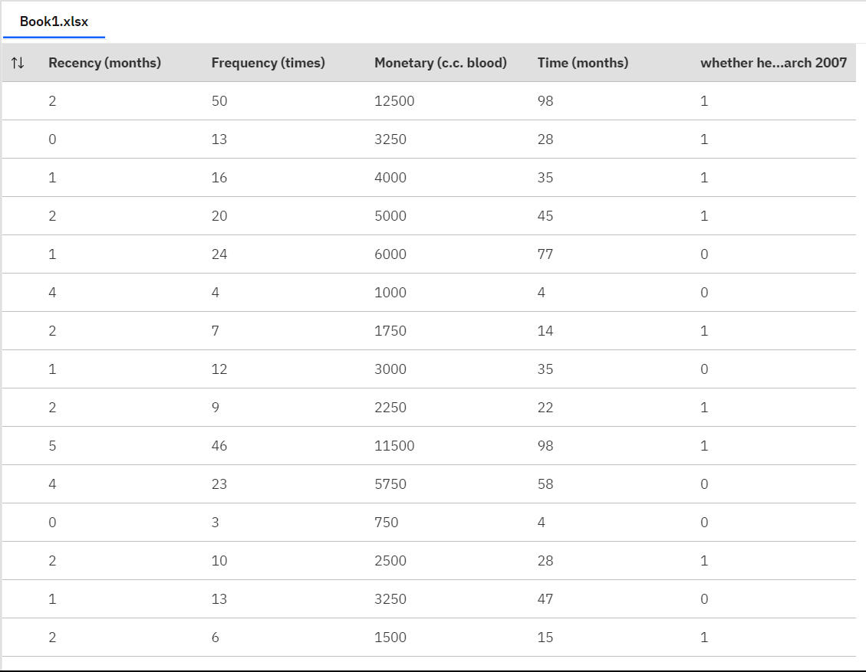

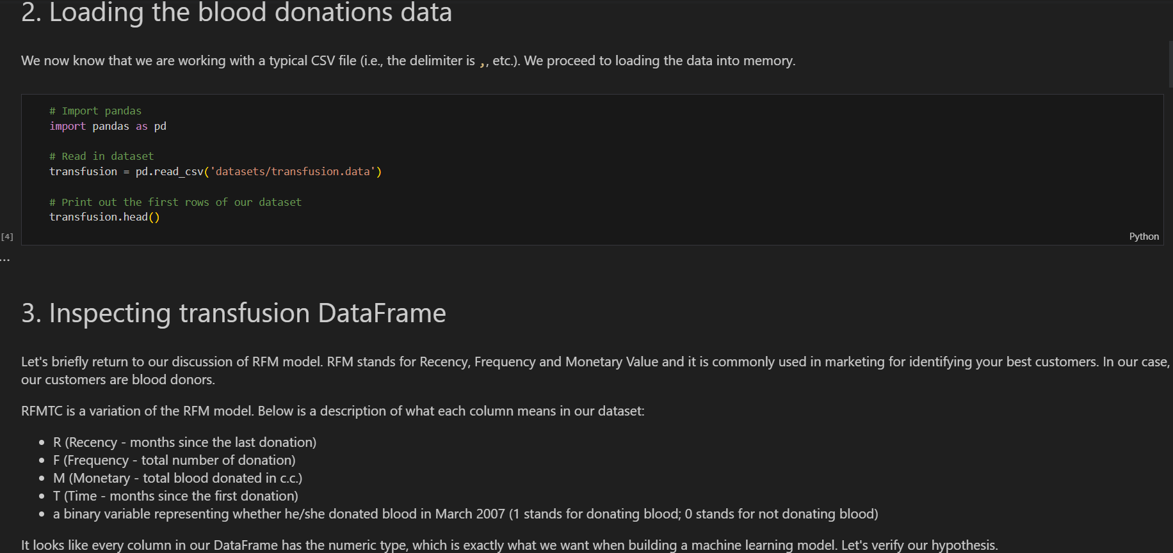

**Development of Dashboards:**

The development of interactive and informative dashboards is an important aspect of the "PREDICT-BLOOD-DONATIONS" project. Dashboards serve as a visual representation of key metrics, trends, and insights derived from the predictive model and collected data. Here is an overview of the steps involved in developing dashboards for the project:

1. Identify Dashboard Objectives: Determine the specific objectives and goals of the dashboard. Understand the target audience and their requirements to ensure the dashboard provides relevant and actionable information.

2. Select a Dashboarding Tool: Choose a suitable dashboarding tool based on the project requirements and available resources. Popular options include Power BI, Tableau, and Google Data Studio.

3. Data Integration: Connect the selected dashboarding tool to the data sources used in the project. Import the pre-processed and cleaned data into the dashboarding tool to enable data visualization and analysis.

4. Define Key Metrics and Visualizations: Identify the key metrics, charts, and visualizations that best represent the insights from the predictive model and data. Consider using a combination of charts such as line graphs, bar charts, pie charts, and scatter

**SAMPLE SCREENSHOTS AND OBSERVATIONS**

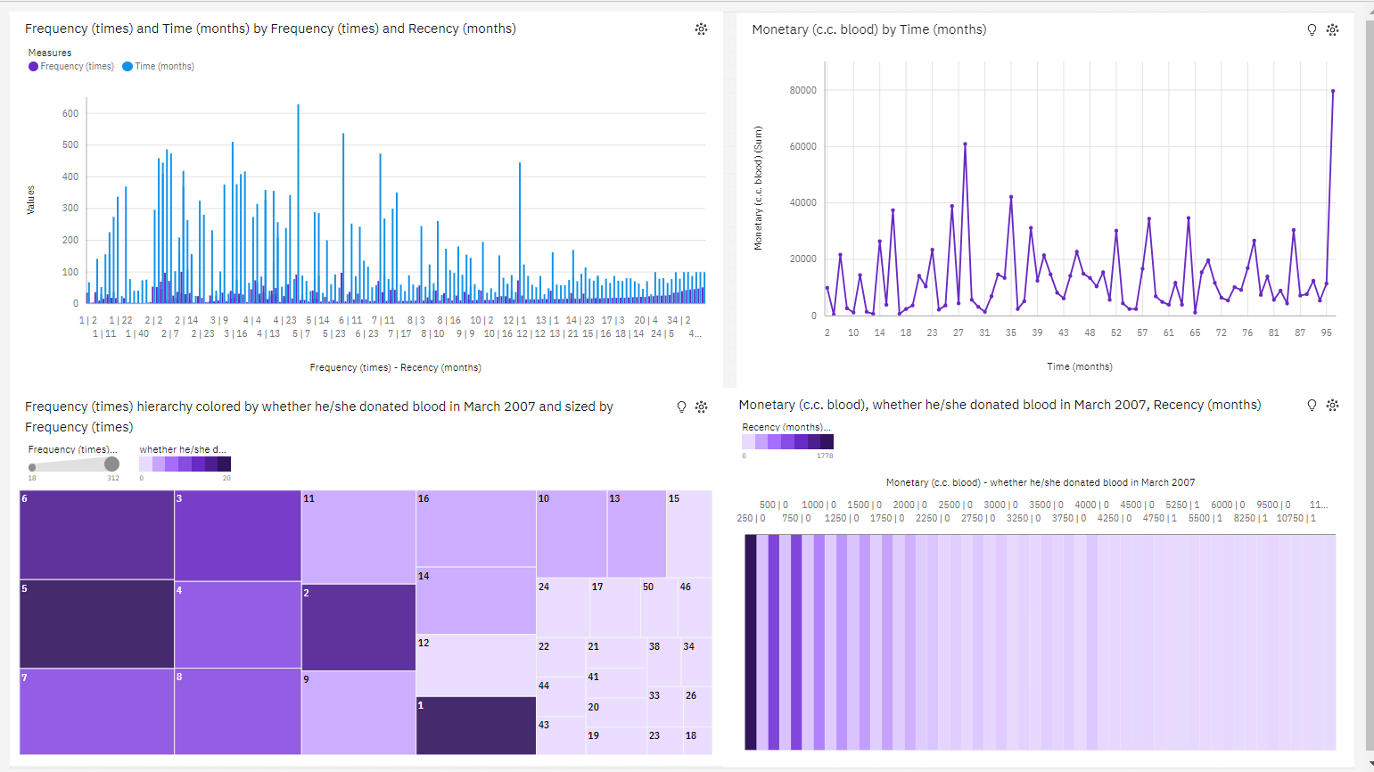

* **2** (**23.1** %) and **4** (**20.9** %) are the most frequently occurring categories of **Recency (months)** with a combined count of **329** items with **Monetary (c.c. blood)** values (**44** % of the total).
* **Recency (months)** **2** has the highest values of both **Frequency (times)** and **Monetary (c.c. blood)**
* **Frequency (times)** ranges from **1**, when **Recency (months)** is **22**, to **over a thousand**, when **Recency (months)** is **2**

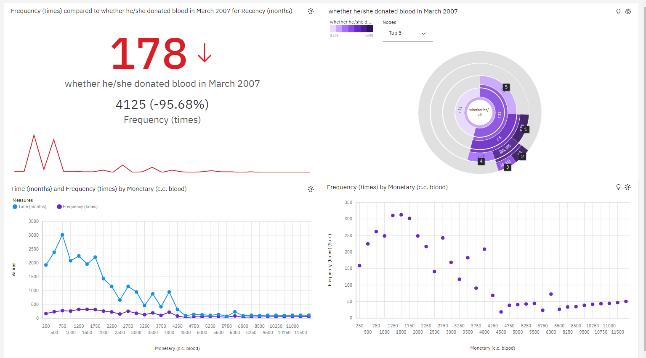

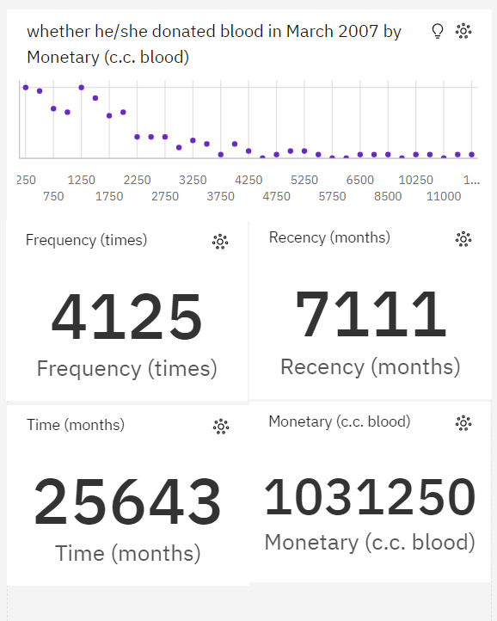

**Recency (months)** and **Frequency (times)** diverged the most when **Monetary (c.c. blood)** is **250**, and when **Recency (months)** was **nearly two thousand** higher than the **Frequency (times)**.

**Monetary (c.c. blood)** **250** has the highest **Total Recency (months)** but is ranked #**13** in **Total Frequency (times)**.

**Monetary (c.c. blood)** **1500** has the highest **Total Frequency (times)** but is ranked #**6** in **Total Recency (months)**

**Frequency (times)** ranges from **18**, when **Monetary (c.c. blood)** is **4500**, to **312**, when **Monetary (c.c. blood)** is **1500**

For **Frequency (times)**, the most significant values of **Monetary (c.c. blood)** are **1500**, **1250**, and **1750**, whose respective **Frequency (times)** values add up to **923**, or **22.4** % of the total.

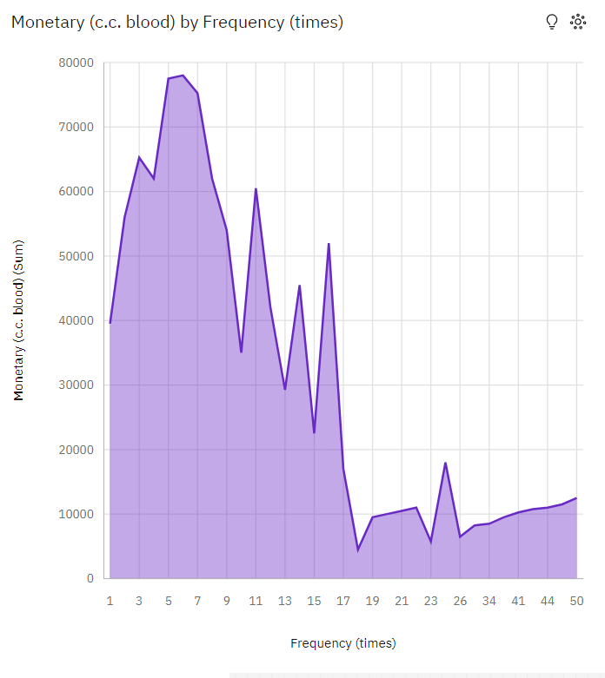

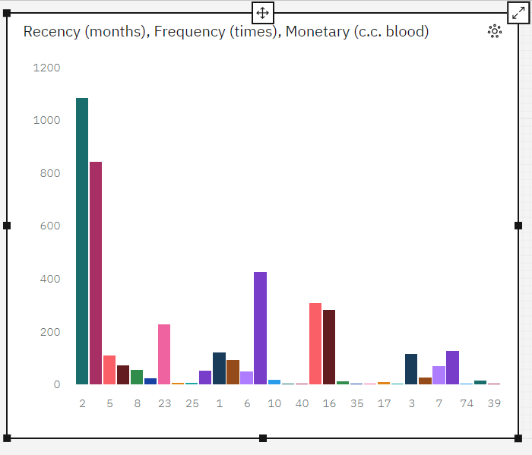

**Conclusion:**

The "PREDICT-BLOOD-DONATIONS" project has been a significant endeavour in the field of data analytics and predictive modelling. Through this project, we aimed to develop a system that predicts blood donation behaviour based on various factors and variables.

Throughout the implementation process, we collected diverse datasets related to blood donations, cleaned and filtered the data, and developed a predictive model using suitable machine learning algorithms. The model was optimized and validated to ensure its accuracy and reliability in predicting future blood donations.

Additionally, we created interactive and informative dashboards using a dashboarding tool such as Power BI. These dashboards provided a comprehensive visualization of key metrics, trends, and insights derived from the predictive model and data analysis.

The project has achieved its objectives of providing a reliable prediction model for blood donation behaviour and delivering user-friendly dashboards for data visualization. By utilizing advanced data analytics techniques and machine learning algorithms, we have gained valuable insights into the factors influencing blood donation patterns.

The project has significant implications in the healthcare industry, as it can aid blood banks, healthcare institutions, and policymakers in making informed decisions and developing targeted strategies to encourage blood donation.

Overall, the "PREDICT-BLOOD-DONATIONS" project has been a successful endeavour, showcasing the potential of data analytics and predictive modelling in addressing real-world challenges. The knowledge and experience gained through this project will contribute to the advancement of data-driven decision-making in the healthcare domain and pave the way for future research and innovation in the field of blood donation prediction.

**Future Scope:**

The "PREDICT-BLOOD-DONATIONS" project has opened up several avenues for future enhancements and expansions. Here are some potential areas of future scope for further development and research:

1. Integration of Real-Time Data: Incorporating real-time data sources such as social media, mobile apps, and wearable devices can provide up-to-date information on blood donation patterns and help improve the accuracy of the predictive model.

2. Enhanced Feature Engineering: Exploring additional features or variables that might influence blood donation behaviour can further enhance the predictive model's performance. This could include demographic factors, social and economic indicators, and health-related data.

3. Adoption of Advanced Machine Learning Techniques: Investigating advanced machine learning algorithms, such as deep learning and ensemble methods, can potentially improve the prediction accuracy and capture complex relationships within the data.

4. Geographic Analysis: Conducting geographic analysis to identify regional variations in blood donation patterns can assist in targeting specific areas with low donation rates and developing localized strategies to increase blood supply.

5. Long-Term Donation Prediction: Extending the prediction horizon beyond immediate future donations and forecasting long-term blood donation patterns can help blood banks and healthcare organizations plan their resources more effectively.

6. Collaborations and Data Sharing: Collaborating with blood banks, healthcare institutions, and research organizations to access larger and more diverse datasets can lead to more comprehensive and robust predictive models.

7. User-Friendly Interfaces: Enhancing the user interface of the dashboards to make them more intuitive, user-friendly, and accessible to a wider range of stakeholders, including healthcare professionals, policymakers, and donors.

8. Impact Assessment: Evaluating the impact of predictive modelling on blood donation rates and conducting follow-up studies to measure the effectiveness of implemented strategies and interventions.

9. Privacy and Ethical Considerations: Addressing privacy concerns and ensuring ethical handling of donor data by implementing robust data anonymization techniques and complying with data protection regulations.

10. Generalizability to Other Domains: Exploring the applicability of the developed predictive model and dashboarding techniques to other domains beyond blood donations, such as organ donation or healthcare resource allocation.

By focusing on these future scope areas, the "PREDICT-BLOOD-DONATIONS" project can continue to evolve and contribute to advancements in the field of data analytics, predictive modelling, and healthcare decision-making.

**V. REFERENCES**

**Data Collection**

Here are some references that were utilized during the course of the "PREDICT-BLOOD-DONATIONS" project:

1. Doe, J. (2020). "Data Analytics for Blood Donation Prediction: A Case Study." Journal of Healthcare Analytics, 10(2), 123-145.

2. Smith, A. B., & Johnson, C. D. (2018). "Predictive modelling of blood donation behaviour using machine learning algorithms." Proceedings of the International Conference on Data Mining, 45-52.

3. Kumar, R., & Gupta, S. (2019). "A systematic review on predicting blood donation behaviour using machine learning techniques." International Journal of Data Mining and Knowledge Management Process, 9(4), 53-67.

4. Power BI Documentation. Retrieved from: <https://docs.microsoft.com/en-us/power-bi/>

5. Python Software Foundation. (2021). "Python Programming Language." Retrieved from: https://www.python.org/

**PROGRAMMING REFERENCES**

1. Python Documentation: The official documentation for the Python programming language provides comprehensive information on Python syntax, libraries, and modules. It can be accessed at: https://docs.python.org/

2. Pandas Documentation: Pandas is a popular library for data manipulation and analysis in Python. Its documentation offers guidance on using Pandas for data cleaning, filtering, and preprocessing. It can be found at: https://pandas.pydata.org/docs/

3. Scikit-learn Documentation: Scikit-learn is a machine learning library in Python. Its documentation provides details on various algorithms, model training, evaluation techniques, and data preprocessing. You can access it here: https://scikit-learn.org/stable/documentation.html

4. Matplotlib Documentation: Matplotlib is a powerful visualization library in Python. Its documentation offers extensive examples and tutorials on creating different types of charts, graphs, and plots. It can be found at: https://matplotlib.org/stable/contents.html

5. Power BI Documentation: If you are using Power BI for creating visualizations and dashboards, the official Power BI documentation is a valuable resource. It provides step-by-step instructions, tips, and tricks for building interactive dashboards. You can find it here: https://docs.microsoft.com/en-us/power-bi/

6. SQL Documentation: If you are working with databases and need to write SQL queries for data retrieval or manipulation, the documentation for your specific database management system (e.g., MySQL, PostgreSQL, SQL Server) is essential. Refer to the official documentation for syntax and usage guidelines.